**Requirements**

Customer log in

1. See the menu of different restaurants
2. Add menu item to cart
3. Send cart to kitchen

Optional

1. Payment Stripe integration?

Kitchen log in

**To do**

1. Learn how bootstrap is done for registration and login page

Restaurant Selection [Done]

* On the home page, display all restaurants
* Every restaurant should show img, name, cuisine, ratings 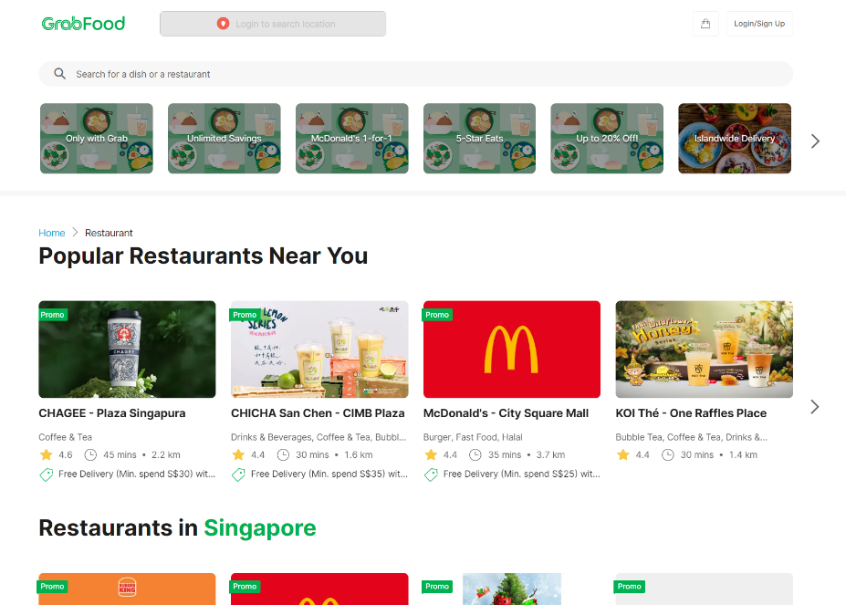
* Clicking into the restaurant will bring to Menu Selection page
* Search by restaurant name (?)

Menu Selection [Done]

* Show restaurant information as before on top
* Display all items on menu
* Show each item img, name, price with a button to add or remove items from cart
* Add on pop up menu that allow users to choose toppings
* Menu should be segmented by categories
* Show only available items as marked by kitchen

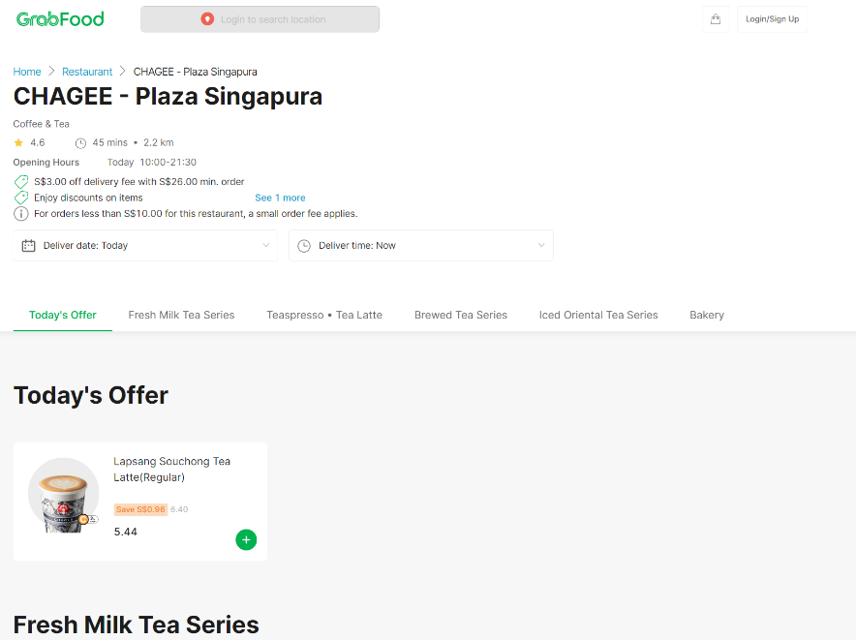

Cart

* Show all items added to cart with name, quantity, price
* Show total price of bill
* Place order button to send order to kitchen
* Change status of order from incart to check out after payment
* Allow stripe payment
* All items in the cart must be from the same restaurant. If items added are from different restaurant vs order in cart, prompt user if user wants to discard items in cart and start a new order ✓
* Improve checkout and payment buttons ✓

Nav Bar

* Include number of items and total bill

History

* If no restaurant is assigned to user, show error message to contact admin ✓,
* Show completed or cancelled orders ✓,
* Kitchen users should see only their own orders, with color coded status ✓,

Current Orders

* If no restaurant is assigned to user, show error message to contact admin ✓,
* Show checkout and accepted orders ✓,
* Kitchen users should see only their own orders, with color coded status ✓,
* For each order in ‘checkout’ status show a card that require the manager to accept or cancel the order ✓
* If the order is cancelled, give a cancellation reason✓

        ('incart', 'In Cart'),

        ('checkout', 'Checked Out'),

        ('accepted', 'Accepted'),

        ('completed', 'Completed'),

        ('cancelled', 'Cancelled'),

* See order details – items, quantity, customer name, special instructions

Menu Management

* Allow user to create and make changes to menu
* Change status of items on menu ✓

**Models**

Order

* ID
* [Customer] - key
* [Restaurant] - key
* Items - ManyToManyField
* total_price
* status
* created_at
* updated_at

User

* Kitchen or Customer

Menu Item

* [Restaurant] - key
* name
* price
* category
* image

Restaurant

* ID
* name
* cuisine
* rating
* opening_hours
* promo

Order Items

* [Order]
* [Menu item]
* quantity
* special_instructions